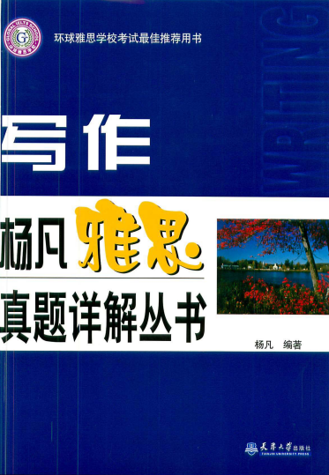
Introduction
This book uses the subject before IELTS with Answers. IELTS for some questions are reused. Therefore, they are subject in all the actual exam, there may be encountered. For each topic, the essay, while providing Chinese translation, and the examiner is given a score. We read the book, like an experienced teacher in the next person counseling.
Answer any questions about IELTS writing can be found in this book. Used not only for the pro forma book IELTS, English writing on the weekdays and a great benefit.
Directory
The first chapter of the IELTS writing test an overview of Chapter II argumentative Zhenti and the Pham Van the Test 1 graduates can not find the work of the Test 2 college students study abroad Test 5 Student evaluation of teachers the Test 6 Select the occupation the Test similar to friends and friends to pay tuition Test exam the Test the Test 8 take care of the elderly Test 9 children lack parents concerned about the Test as early as 10 to send their children to kindergarten Test 11 to spank a child Test 12 family relationship was not close Test 13 modern science and technology, environmental pollution energy consumption

